Flash firmware to HeishaMonBoth board
- Upgrade file by Webserwer
Go to Setting > Firmware

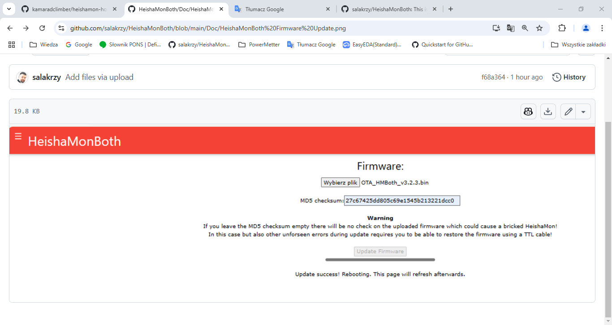
- Using USB to TTL Serial converter
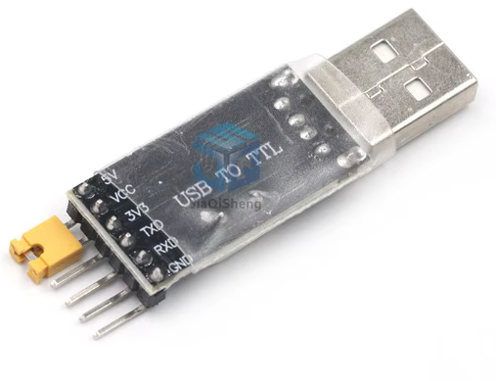
Copy the directory https://github.com/salakrzy/HeishaMonBoth/tree/main/build_output to your computer
Close “boot” pins on the board and connect the “ UART0” pins with USB converter.
Disconnect board from Heat pump!!!! Power will be provided by converter.
Remember Tx pin from board goes to Rx pin in converter and Rx from board goes to Tx.
Connect only the Tx, Rx, GND and +5V pins.
Go to the local directory and run OTA_flash.bat
You could see something like this
esptool.py v2.3.1
Connecting........_____....._____....._____.....___
Chip is ESP32D0WDQ5 (revision (unknown 0xa))
Features: WiFi, BT, Dual Core, Embedded Flash, VRef calibration in efuse
Uploading stub...
Running stub...
Stub running...
Changing baud rate to 921600
Changed.
Configuring flash size...
Auto-detected Flash size: 4MB
Compressed 18928 bytes to 13069...
Wrote 18928 bytes (13069 compressed) at 0x00001000 in 0.2 seconds (effective 809.8 kbit/s)...
Hash of data verified.
Compressed 3072 bytes to 157...
Wrote 3072 bytes (157 compressed) at 0x00008000 in 0.0 seconds (effective 1536.0 kbit/s)...
Hash of data verified.
Compressed 1102304 bytes to 665904...
Wrote 1102304 bytes (665904 compressed) at 0x00010000 in 9.4 seconds (effective 937.4 kbit/s)...
Hash of data verified.
Compressed 57344 bytes to 722...
Wrote 57344 bytes (722 compressed) at 0x00391000 in 0.0 seconds (effective 28671.9 kbit/s)...
Hash of data verified.
Leaving...
Hard resetting via RTS pin...

d:\...\...\Flash HeishamonBoth>pause
Press any key to continue . . .

Disconnect boot jumper and restart power

You can clear all ESP32 flash memory using command eraseesp.bat

